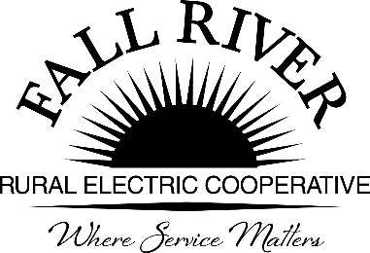
AGENDA

Monday, April 25, 2022
Fall River Rural Electric Cooperative, Inc.
Administrative Board Committee Meeting

Start Time: 9:00 a.m. Stop Time: 10:00 a.m.
*Items that need action taken.
Meeting will start prior to the Fall River Rural Electric Board Meeting

9:00 a.m. 1. Preliminary
Call to Order
9:05 a.m. 2. *Approval of Agenda
9:10 a.m. 3. *Approval of Minutes of February 28, 2022 (Included in Packet)
9:15 a.m. 4. *Review Scholarship Recommendations from Committee
(Included in Packet)

- West Yellowstone Doug Schmier
- Teton/Driggs Anna Lindstedt
- North Fremont Jodi Stiehl
- South Fremont Brent Crowther
- Madison Brent Crowther
- Sugar-Salem Bryan Case
- Rigby Bryan Case
- Ririe Bryan Case
- At Large Georg Behrens
- Helping Hands Georg Behrens
- Wyoming Georg Behrens
- Lineman Committee

Scholarships Allocations are as follows:
At Large 2
Helping Hands 3
Lineman College 1
West Yellowstone H.S. 3
North Fremont H.S. 7
South Fremont H.S. 1
Teton H.S. 10
Wyoming 1
Sugar/Salem 1
Madison 1
Rigby 1
Ririe 1
Total 32

Note:
- There will be at least two scholarships, Wyoming and Helping Hands, which will be available for scholarship applications where applicants exceed available scholarships for a given school or category. Please come prepared to advocate for applicants who ranked high but did not receive a scholarship. The committee will discuss applicants and decide at the Administrative Committee Meeting.

9:35 a.m. 5. Award Ceremony Dates and Times (Included in Packet)
9:55 a.m. 7. Adjournment
Members: Chairperson - Jeff Keay, Doug Schmier, Georg Behrens, Jodi Stiehl, & Anna Lindstedt

