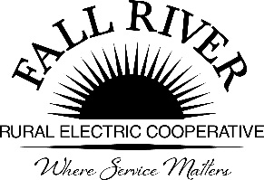
AGENDA
Monday, February 28, 2022
Fall River Rural Electric Cooperative, Inc.
Administrative Board Committee Meeting
Click on blue box for link

Start Time: 9:00 a.m. Stop Time: 10:00 a.m.
*Items that need action taken.

Meeting will start prior to the Fall River Rural Electric Board Meeting

9:00 a.m. 1. Preliminary
Call to Order

9:05 a.m. 2. *Approval of Agenda

9:10 a.m. 3. *Approval of Minutes August 23, 2021 (Included in Packet)

9:15 a.m. 4. Review Scholarship Materials:
- Available Scholarship Dollars/Funding (Included in Packet)
- Timeline for Receiving and Reviewing Scholarship Applications. (Included in Packet)
- Scholarships Assigned per School District (Included in Packet)
- Guidelines for Fall River Scholarships (Included in Packet)
- Provide Over View of the Ranking Spreadsheet (Included in Packet)
- Chair to make assignments from the Committee
- Energy Partner Scholarship Raffle available to Scholarship Applicants attending the Energy Expo – Annual Meeting on June 11th
9:45 a.m. 5. 2022 Donations Summary (Included in Packet)

9:55 a.m. 7. Adjourn – Next Meeting is Scheduled for April 25th at 9:00 a.m.

Members:
Chairperson - Jeff Keay, Doug Schmier, Georg Behrens, Jodi Stiehl, & Anna Lindstedt

