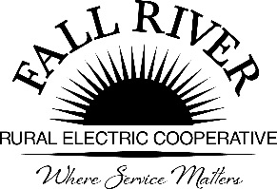
AGENDA
Monday, February 27, 2023
Fall River Rural Electric Cooperative, Inc.
Administrative Board Committee Meeting
Click on blue box for link

Start Time: 9:00 a.m. Stop Time: 10:00 a.m.
*Items that need action taken.

Meeting will start prior to the Fall River Rural Electric Board Meeting

9:00 a.m. 1. Preliminary
Call to Order

9:03 a.m. 2. *Approval of Agenda

9:05 a.m. 3. *Approval of Minutes April 25, 2022 (Included in Packet)

9:10 a.m. 4. Review Scholarship Materials:
- Available Scholarship Dollars/Funding (Included in Packet)
- Timeline for Receiving and Reviewing Scholarship Applications. (Included in Packet)
- Scholarships Assigned per School District (Included in Packet)
- Chair to make Committee assignments for each school
- Energy Partner Scholarship Raffle available to Scholarship Applicants attending the Energy Expo – Annual Meeting on June 11th
9:40 a.m. 5. *Lineman Scholarship Application (Included in Packet)

9:45 a.m. 6. Hendricks Scholarship Report and Thank you (Included in Packet)

7. 2023 Donations Summary (Included in Packet)

9:55 a.m. 8. Adjourn – Next Meeting is Scheduled for April 24, 2023 at 9:00 a.m.

Members:
Chairperson - Jeff Keay, Doug Schmier, Georg Behrens, Jodi Stiehl, & Anna Lindstedt

