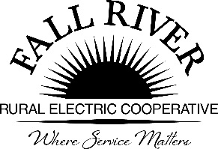
AGENDA
Monday, February 23, 2025
Fall River Rural Electric Cooperative, Inc.
Administrative Board Committee Meeting

Start Time: 9:00 a.m. Stop Time: 10:00 a.m.
*Items that need action taken.

Meeting will start prior to the Fall River Rural Electric Board Meeting

9:00 a.m. 1. Preliminary
Call to Order

9:03 a.m. 2. *Approval of Agenda

9:05 a.m. 3. *Approval of Minutes April 21, 2025 (Included in Packet)

9:10 a.m. 4. Review Scholarship Materials:
- Timeline for Receiving and Reviewing Scholarship Applications. (Included in Packet)
- Scholarships Assigned Per School District (Included in Packet)
- Chair to make Committee Assignments for:
  - Teton High School and Wyoming
  - West Yellowstone
  - North Fremont
  - South Fremont
  - Sugar/Salem
  - Madison
  - Rigby
  - Ririe
  - Helping Hands, At Large Scholarship & Lineman if Any.
- Energy Partner Scholarship Raffle Available to Scholarship Applicants Attending the Energy Expo – Annual Meeting on June 13th
- Scholarship Ranking Matrix (Included in Packet)
9:40 a.m. 5. 2025 Donations Summary (Included in Packet)

9:55 a.m. 7. Adjourn – Next Meeting is Scheduled for April 20, 2026, at 9:00 a.m.

Members:
Chairperson - Jodi Stiehl, Jeff Keay, Doug Schmier, Georg Behrens, & Anna Lindstedt

