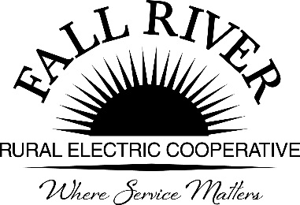
AGENDA

Monday, April 20, 2026
Fall River Rural Electric Cooperative, Inc.
Administrative Board Committee Meeting

Start Time: 9:00 a.m. Stop Time: 10:00 a.m.
*Items that need action taken.
Meeting will start prior to the Fall River Rural Electric Board Meeting

9:00 a.m. 1. Preliminary – Call to Order

9:02 a.m. 2. *Approval of Agenda
9:05 a.m. 3. *Approval of Minutes of February 23, 2026 (Included in Packet)
9:10 a.m. 4. Scholarship Allocation Per School (Included in Packet)

9:20a.m. 5. *Review Scholarship Recommendations from Committee
(Included in Packet)

- At Large Jeff Keay
- Helping Hands Jeff Keay
- South Fremont Georg Behrens
- Madison Bryan Case
- Sugar-Salem Bryan Case
- Rigby Husk Crowther
- Ririe Husk Crowther
- Teton Anna Lindstedt
- Wyoming Anna Lindstedt
- North Fremont Jodi Stiehl
- West Yellowstone Doug Schmier
- Lineman Jeff Keay

Scholarships Allocations are as follows:
At Large 2
Helping Hands 3
South Fremont H.S. 1
Madison 1
Sugar/Salem 1
Rigby 1
Ririe 1
Teton H.S. 10
Wyoming 1
North Fremont H.S. 7
West Yellowstone H.S. 3
Lineman College 1
Total 32

Note:
- There were two Lineman scholarship applications submitted, and we will ask the Committee to consider approving both.

9:45 a.m. 6. Award Ceremony Dates and Times (Included in Packet)

9:55 a.m. 7. Adjournment
Members: Chairperson – Jodi Stiehl, Doug Schmier, Georg Behrens, Jeff Keay, & Anna Lindstedt

